IRB SYNOPSIS OF PROPOSAL

Every application submitted for review and approval shall have attached to it a page organized in numerical brief paragraph form as outlined below.

Title of Study
Eating Behaviors and Body Satisfaction – Application # 2009T6154

- Identify the sources of the potential subjects, derived materials or data. Describe the characteristics of the subject population, such as their anticipated number, age, sex, ethnic background, and state of health. Identify the criteria for inclusion or exclusion. Explain the rationale for the use of special classes of subjects, such as fetuses, pregnant women, children, institutionalized mentally disabled, prisoners, or others, especially those whose ability to give voluntary informed consent may be in question.

- Source of potential subjects – undergraduates at Texas State will be solicited in classes to volunteer for class extra credit (amount specified by course instructors in advance, 2 or 4 points out of typically 400). The ages are >18. Sex and ethnicity are anticipated to be distributed like the Texas State undergraduate population; slightly more females than males; Hispanic the largest percent minority ethnicity. Health is anticipated to be good.
- The criteria for inclusion is specified in the consent form: “Please either decline participation or perform the alternative if you feel that completing a survey on eating behaviors and body satisfaction, with questions like those shown above, would create any unusual level of distress.” Thus, the criteria for inclusion is a signed consent form with the understanding that only persons who feel that completing a survey on eating behaviors and body satisfaction, with questions like those shown above, would not create any unusual level of distress.
- Excluded are the use of special classes of subjects, such as fetuses, pregnant women, children, institutionalized mentally disabled, prisoners, or others, especially those whose ability to give voluntary informed consent, and anyone who chooses to decline or withdraw at any time.
- Characteristics - Approximately 400, 18-30 year-old Texas State University undergraduates will be recruited from undergraduate psychology classes. The frequencies of males and females, as well as ethnic distributions will be similar to those of the university as a whole. No one will be excluded from participation due to gender or ethnicity. Participation is voluntary with a course extra credit incentive offered by instructors for participation. Students may decline participation in the research and still gain the extra credit points by writing a 2 page paper about eating behavior and body satisfaction research. Prior to participating, participants must read and sign a consent statement.

- Describe the procedures for recruitment of subjects and the consent procedures to be followed. Include the circumstances under which consent will be solicited and obtained, who will seek it, the nature of information to be provided to prospective subjects, and the methods of documenting consent. (Include applicable consent form(s) for review.) If written consent is not to be obtained, this should be clearly stated and justified.

Participants will be recruited in undergraduate psychology classes. Written informed consent will be obtained.

THE SOLICITATION WILL STATE: “ Dr. Harvey Ginsburg, Department of Psychology at Texas State University is conducting a study on eating behaviors and body satisfaction. Participants are needed for eating behaviors and body satisfaction research. Time required will be about 20-30 minutes. Preferred are participants who would like some information about eating behaviors and body satisfaction. Participants will self-report their height and weight. They will be asked to complete questions about eating behaviors and body satisfaction. Credit will be provided for participants who complete the research. Opportunities for credit are still available for those students who do not want to participate in the research study (e.g., a paper about eating behaviors and body satisfaction). Participants may also obtain credit for the study by completing a 2 page review paper on eating behaviors and body satisfaction, submitted by email attachment to the investigator (hg01@txstate.edu)before November 30, 2009. Only those participants who either complete the study or the alternative paper will be provided credit for participation. If you have any questions, please contact Dr. Harvey Ginsburg, hg01@Txstate.edu.”

- Describe the project’s methodology in detail. If applicable, detail the data collection procedures, the testing instruments, the intervention(s), etc. If using a survey, questionnaire, or interview, please provide a copy of the items or questions.

Students will complete the surveys in classrooms and turn the consent forms in separately from the survey (which has no identifiers). They will be randomly assigned to either a survey condition using personal pronouns “I” feel, or a survey where they are asked to evaluate how a fictitious person would respond initial “KW’ replace “I” on the alternate survey. The complete “I” survey is shown below. In the alternate survey instrument, the initials “KW” replaces personal pronoun “I”.

INSERT survey word doc. Attachment here.
------------------------------------------------------------------------------------------------
This is an anonymous survey about eating behaviors and body satisfaction. This means that is impossible to identify any individual because the surveys/answer sheets have no identifiers on them. There are no identifiers and your responses are completely anonymous. The Consent Forms that were signed will be turned in separately from and kept isolated and from the group of anonymous surveys/answer sheets. The data will be analyzed as a whole group and no individual can or will be identified.
The 35 questions on this anonymous survey are divided into several sections about eating behaviors and body satisfaction: (a) Participants’ characteristics (b) Behavior Attitudes (c) Subjective Social Norms; Perceived Behavior Control (d) Intentions (e) Behaviors (f) Body Satisfactions and (g) Debriefing and Risk/Benefits Appraisal (required by University policy).
PLEASE ANSWER THE ANAONYMOUS SURVEY QUESTIONS HONESTLY AND FAITHFULLY. YOUR SINCERE TRUTHFULNESS IS NECESSARY.
Demographic Information
01. Your age:
02. Your sex: Female (1)/Male (2)
03. Your Ethnicity:
04. Your Height in feet and inches:
05. Your Weight in pounds:
06. Years to date as a college student
Behavi or Attitudes
07. I feel extremely guilty after eating.
08. I give too much time and thought to food.
09. I am terrified about being overweight.
10. I am preoccupied with the desire to be thinner.
11. I think about burning up calories when I exercise.
12. During the past six months, how important has your weight or shape been in how you feel about or evaluate yourself as a person- as compared to other aspects of your life, such as how you do at work, as a student, or how you get along with other people?
Subjective Norms
13. Most people who are important to me would want me to watch my diet.
14. I feel I am overweight despite others saying you are too thin.
15. I eat moderately in front of others and stuff myself when they are gone.
16. I would say the people close to me would approve of my eating patterns.

17. Weight is more important to me compared to my peers.

18. I feel others pressure me to eat.

PERCIEVED BEHAVIORAL CONTROL
19. It’s easy to control my thoughts of food.

20. I struggle to display self-control around food.

21. I worry about having lost control over how much you eat?

22. I would say food dominates my life.

23. I could break potentially unhealthy eating patterns.

24. I am concerned I have lost control over how much I exercise.

INTENTIONS
25. I often work out with the intention of losing weight.
26. I plan dieting.

27. I plan of the calorie content of food that I eat.
28. I plan on eating a healthy amount of food regularly in the near future.

29. I plan on avoiding foods with a high carbohydrate count.

30. I have planned to vomit in order to lose weight.
BEHAVIOR
31. I avoid eating when I am hungry
32. I engage in dieting behavior.
33. I make myself sick because I feel uncomfortably full?
34. I eat or drink in secrecy.
35. I have gone on eating binges where I feel that I might not be able to stop.
36. I vomit after meals.
BODY SATISFACTION
37. On a scale from 1(low) -7 (high), how satisfied are you with your current body image?
38. On a scale from 1(low) -7 (high), how much would you like to change your current body image.
39. On a scale from 1 (low) to 7 (high), how do you think new people that you first meet appraise you with your current body image?
40. On a scale from 1 (low) to 7 (high), how do you think your old friends appraise you with your current body image?
41. Look at the drawings below. Which one (1-9) do you think is most similar to you?
42. Look at the drawings below. Which one (1-9) do you think is your ideal body image?
1 2 3 4 5 6 7 8 9
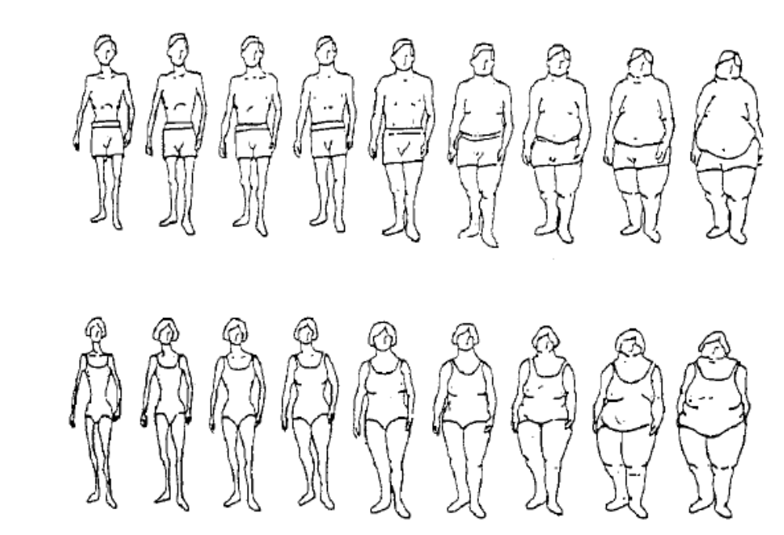

43. Estimate the extent to which you think that you may have an eating disorder where you stay thin (< 85% normal body weight) by greatly restricting your caloric content, which may or may not be combined with purging behaviors after eating. (1 strongly disagree – 7 strongly agree).
44. Estimate the extent to which you think that you may have an eating disorder where you stay thin (but somewhere above 85% normal body weight) by utilizing behaviors that purge caloric intake (e.g., vomiting, laxatives, enemas, excessive exercise) - (1 strongly disagree – 7 strongly agree).
45. Estimate the extent to which you think that you may have an eating disorder where you are overweight, overeat and do not make any effort to reduce calories. (1 strongly disagree – 7 strongly agree)
46-48. We want to know what you think! Please provide any and all of your opinions or ideas that you have about people you meet who may have one of these eating disorders. Feel free to continue writing on the back of the page.
46. People who are thin and maintain less than 85% normal body weight by greatly limiting caloric intake

47. People who are thin, but above 85%, and who follow eating with some behavior(s) to reduce their caloric intake by purging calories (vomiting, laxatives, enemas, extreme exercise)

48. People who are overweight, who overeat and do not make any effort to reduce calories.

Debriefing:
49. The probability of harm or injury -physical, psychological, social, or economic -occurring as a result of participation in a research study defines risk On a scale of 1-10, with 1 being no risk and 10 being significant risk, rate the overall risk to subjects in your project.
50. A valued or desired outcome; an advantage defines benefit. On a scale of 1-10, with 1 being no benefit and 10 being significant benefit, rate the overall benefits to subjects in your project.
- What was the purpose of the study? The purpose of this study was to determine how a psychological theory (Azgen’s Theory of Planned Behaviors) can be used to study eating behaviors and body satisfaction. Azgen’s model is that Behaviors that require planning are produced by the strength and interactions of these components: Behavior Attitudes, Subjective Social Norms, Perceived Behavior Control and Intentions to carry out the targeted behavior. Further, we wanted to examine whether any differences appear when the personal pronouin “I” is replaced with a fictitious person and the questions become hypothetical, e.g., how would KW feel. It is anticipated that more people will self-report unusual eating behaviors and body satisfaction when the survey is posed as being from a fictitious KW than the personal pronoun “I” version.

- How will the data collected from this study be examined? A group-statistical technique will be used to test the hypotheses that for eating behaviors and body satisfaction, self-reported Behaviors are predicted best by Intentions, followed, in order, by Perceived Control, Subjective Norms, and Behavior Attitudes. The “KW” fictitious person survey will also be compared to the “I” personal pronoun ones. We also predict that participants body/weight ratios and self-reported opinions about themselves and others (43-48) will be related to self-reported eating behaviors and body satisfaction. Finally, we predict that perceived benefits will exceed perceived risks (49-50).

- Whom may I contact about the results and when may they be accessed? A copy of the Consent Form is available upon request. It has this information: contact the researcher responsible for conducting the study: Dr. Harvey Ginsburg (hg01@txstate.edu); the results will be available by the beginning of the following semester.

- Please feel free to ask any questions or to state any concerns to the person collecting the surveys/answer page after you have finished. Please describe any concerns or questions about the study that you wish to have answered here.

Debriefing (continued)

Eating disorders can become life-thratening. It is estimated that between 5-10% of college students may suffer from an eating disorder. There are technically 3 types of medically defined eating disorders: (1) anorxia (<85% normal body weight), (2) bulimia (somewhat > 85% body weight where purging is used to remove caloric intake, and (3) obesity, when excessive calories are consumed and little or no effort is made to reduce the caloric intake. As a benefit of participating in the anonymous survey, please feel free to detach this information page
from the survey before turning it in; these are links to eating behaviors and treatment for eating disorders.

Eating Disorders: “It’s Not About Food, Weight or The Body”
http://behavioralhealthcentral.com/index.php/2009091177899/Special-Features/eating-disorders-its-not-about-food-weight-or-the-body.html

Eating Disorders: Articles
http://psychcentral.com/resources/Eating_Disorders/Articles/
http://www.sciencedaily.com/articles/health_medicine/eating_disorders/

-------------------------------------------------------------------------------------------------
END OF SURVEY INSTRUMENT

- Describe any potential risks — physical, psychological, social, legal or other — and state their likelihood and seriousness. Describe alternative methods, if any, that were considered and why they will not be used.

The risks to participants are minimal – asked to evaluate eating behaviors and body satisfaction may produce some mild discomfort, but any subjective discomfort is immediately removed since survey responses will be taken anonymously. There is no report in the psychological literature of any harmful effects of reporting perceptions eating behaviors and body satisfaction. We considered an alternate method involving actual weight and height measurements rather than self-reports. This will not be used because being actually weighed and measured may produce more potential distress than self-reports.

- Describe the procedures for protecting against or minimizing any potential risks and include an assessment of the likely effectiveness of those procedures. Include a discussion of confidentiality safeguards, where relevant, and arrangements for providing mental health or medical treatment, if needed.

To minimize risk, we are not having participants actually weighed and measured, as required by others investigators in some previous research. To assure anonymity, participants’ surveys will have no identifiers. To assure anonymity, the consent form will be administered and collected separately, prior to the survey instrument. The survey instrument has no name or number appear on the consent form that can be connected to the survey responses. The data will be entered with no names or numbers attached to the survey responses. Further, a group-statistical analysis will be performed upon the data. Names will appear only on the consent form and the consent form will not be attached to the survey instrument, thus further assuring anonymity. No individual's scores will be identified by name. Further, all participants will be debriefed at conclusion and will be asked to assess and describe any potential risks and benefits of participation.

- Describe and assess the potential benefits to be gained by the subjects, as well as the benefits that may accrue to society in general as a result of the proposed study.

Participants will benefit from a better understanding of research on eating behaviors and body satisfaction that will be described during the debriefing. Participants’ will gain some extra class credit. Regarding general societal benefits, the underlying mechanism of attitudes leading to eating behaviors and body satisfaction will be examined. These preliminary studies may lead to a better understanding of attitudinal determinants of eating behaviors and body satisfaction.

- Clearly describe any compensation to be offered/provided to the participants. If extra credit is provided as an incentive, include the percentage of extra credit in relation to the total points offered in the class. Also, if extra credit is provided, describe alternatives to participation in your research for earning extra credit.

Extra credit is provided as an incentive. Most instructors offer either 2 or 4 points out of 400 e.g., .05 or .01 of total points. The alternative is described in the consent form. Opportunities for credit are still available for those students who do not want to participate in the research study (e.g., a paper about eating behaviors and body satisfaction). Participants may also obtain credit for the study by completing a 2 review paper on eating behaviors and body satisfaction submitted by email attachment to the investigator (hg01@txstate.edu)before November 30, 2009. Only those participants who either complete the study or the alternative paper will be provided credit for participation.

- Discuss the risks in relation to the anticipated benefits to the subjects and society.

On a scale of 1-10 the risks to participants and society is minimal (1) while the anticipated benefits to participants and society are above minimal (2). Benefits outweigh risks because: There are no reports of risk from completing surveys on eating behaviors and body satisfaction in the extant psychological literature. Participants will benefit by being given information during debriefing about eating behaviors and body satisfaction which may aid their own self-understanding. This project is basic research and will add to the knowledge base about the determinants of eating behaviors and body satisfaction.

- Identify the specific sites/agencies to be used as well as approval status. Include copies of approval letters from agencies to be used (note: these are required for final approval). If they are not available at the time of IRB review, approval of the proposal will be contingent upon their receipt.

No agents or agencies, other than Texas State University students and facilities will be used

- If you are a student, indicate the relationship of the proposal to your program of work and identify your supervising/sponsor faculty member.

Not applicable.

- In the case of student projects, pilot studies, theses, or dissertations, evidence of approval of Supervising Professor or Faculty Sponsor should be included. Thesis and dissertation proposals must be approved by the student’s committee before proceeding to the IRB for review.

Not applicable.

- If the proposed study has been approved by another IRB, attach a copy of the letter verifying approval/disapproval and any related correspondence. If the proposed study has not been reviewed/approved by another IRB, please state this explicitly.

Not applicable.

- Identify all individuals who will have access, during or after completion, to the results of this study, whether they be published or unpublished.

Students who have completed the CITI basic course for social and behavioral science: Steven Sheffield, Loren Foster, Deborah Lim, Kalah Blankenship, Lela Pickett, Scott Ramos, Briana Saltis, Desiree Lewis.

In addition to this synopsis, you are required to submit all relevant documentation for review. This may include, but is not necessarily limited to: 1) recruiting documents (e.g., flyers, letter, e-mails, brochures, etc.), 2) a consent form, 3) an assent form, 4) letters of approval from relevant organization(s), 5) surveys/instruments/questionnaires, esp. those created by the researcher, 6) a list of questions that the researcher may ask (e.g., focus groups questions, questions for qualitative studies, etc.), and 7) all documents in translated versions.

